

**Penumaka Ajay(Team Lead)**

**Shaik Baji**

**Shaik Irfan**

**Shaik Mohammadhaneef**

**Shaik Rajeek**



**Web**



**-**



**Scraping /**



**Regression**



**Project Presentation**





Goal







Forecast flight prices



Selecting optimum time for travel



Selecting the cheapest flight to the desired destination

Goal





Scraping





Scraping

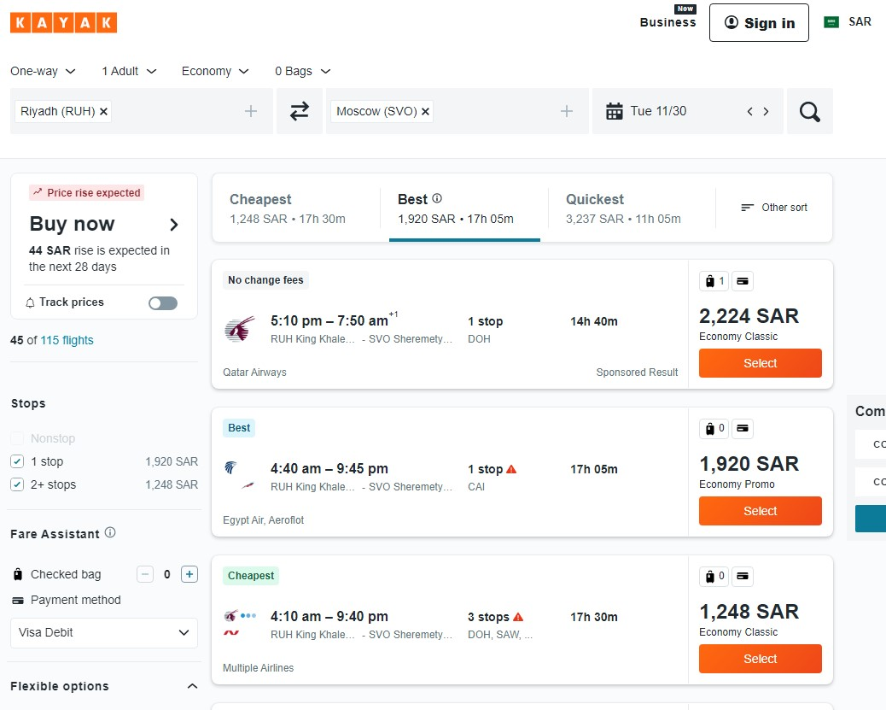



Source & Destination



Date (Feb to April, 2022)



Price



Duration



Total Stops



Airline





Scraping Tool

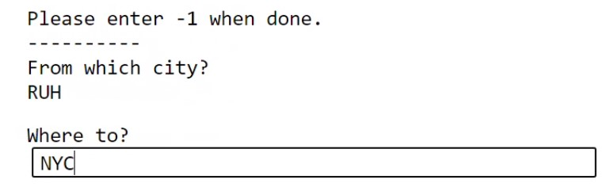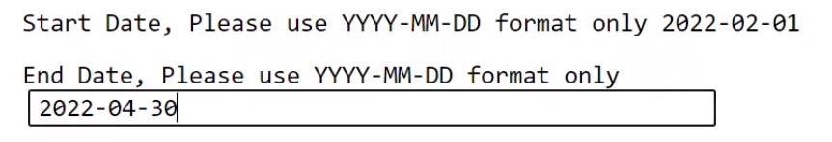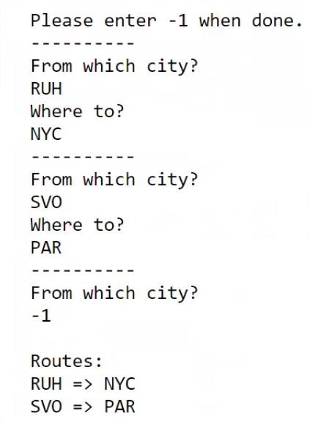



Scraped Routes



RUH

PAR

NYC

SVO





Problems

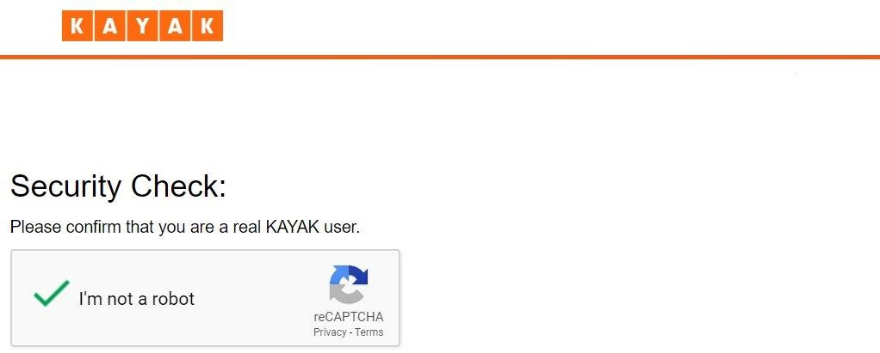



Closing and opening the driver every 10 days (pages).



Alert the user to go solve the captcha and resume scraping.

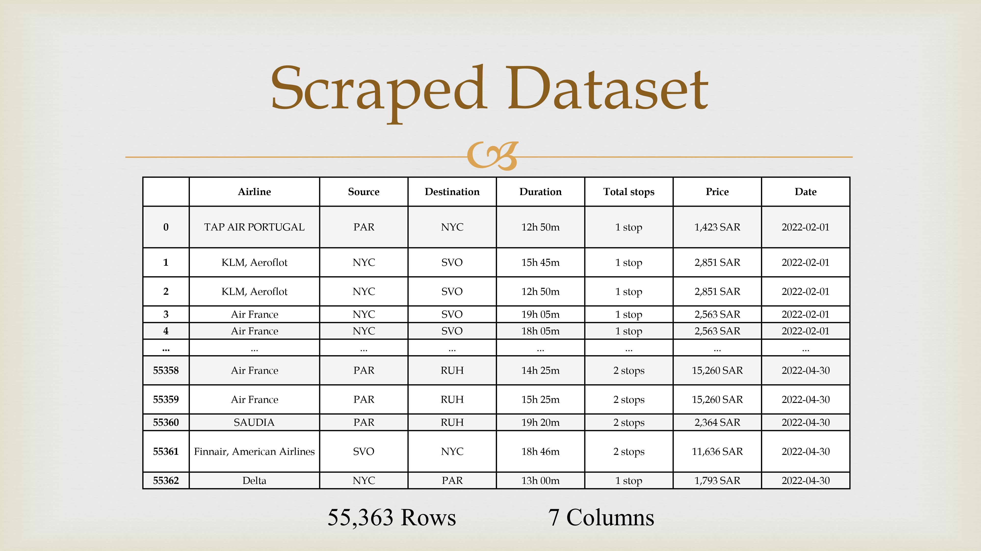





EDA

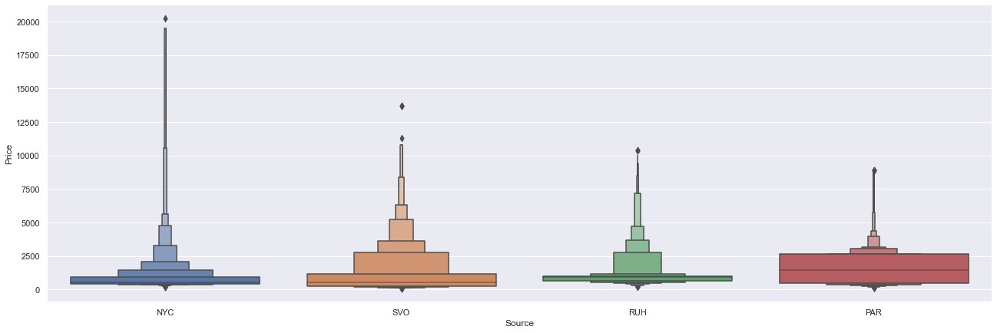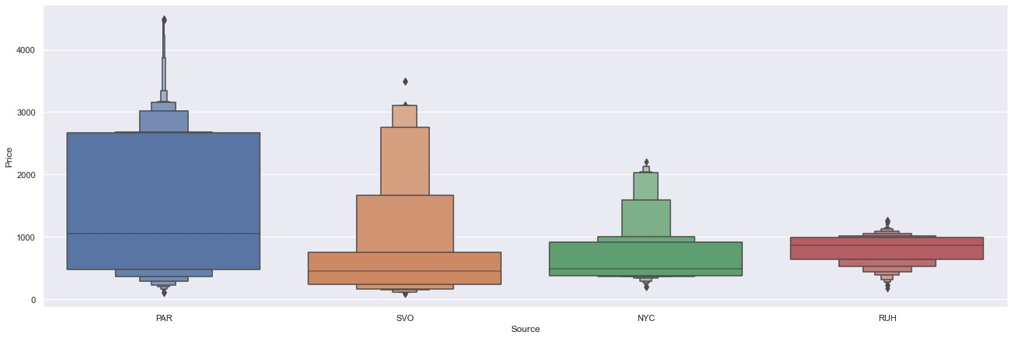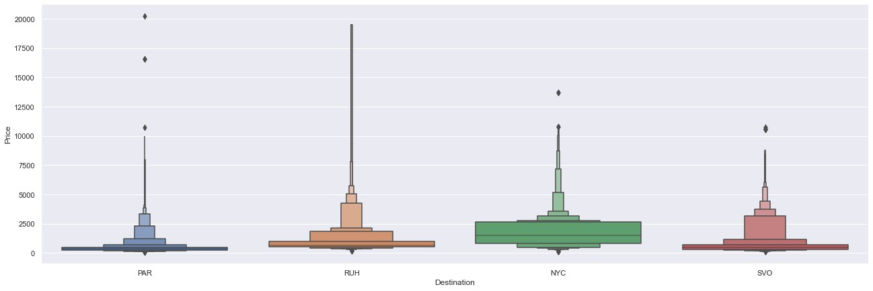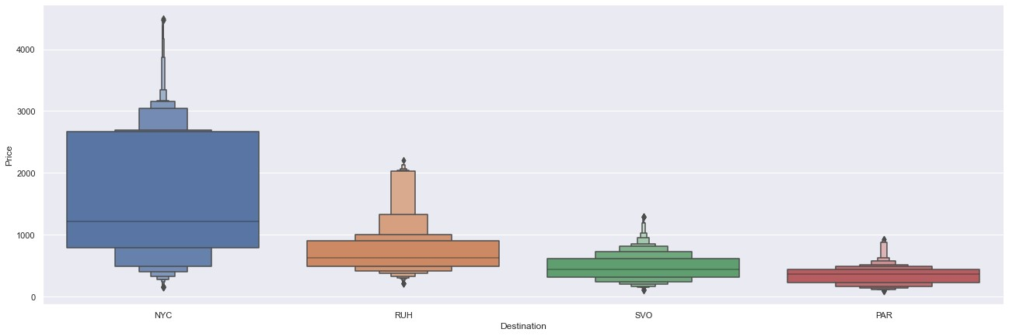

Features

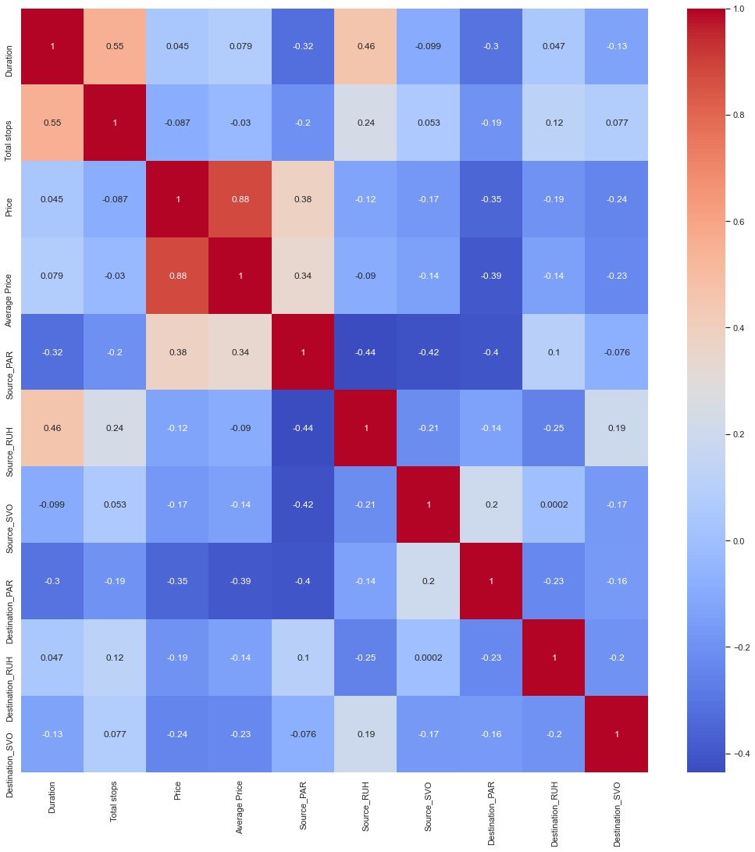



Source (4)



Destination (4)



Total Stops



Average Price per Airline



Duration



Price





Results and

Experiments





**Model / Metric**

**Train (60%)**

**Val (20%)**

**MAE**

**MSE**

**RMSE**

**Linear**

**Regression**

0.804

0.789

225.09

152995.68

391.15

**Polynomial (5)**

0.888

0.871

149.72

93366.04

305.56

**Lasso**

0.803

0.789

223.49

153097.06

391.28

**Ridge**

0.804

0.789

225.08

152995.61

391.15

**Elastic Net**

0.790

0.775

224.41

163034.63

403.78

**Random Forest**

0.965

0.945

61.72

40035.32

200.09

Results





Other Experiments



Feature Importance



Feature Scaling



Hyperparameter Tuning



Randomized Search CV





Result



Retraining the random forest model on train +

val

and scoring on test.



Before and after hyperparameter tuning using random search CV:

Metric

MAE

MSE

RMSE

Before

61.87

40409.87

201.02

After

64.19

41409.93

203.49





Result

**Predicted Price (USD)**

**Actual Price (USD)**

**0**

2676.530000

2676.53

**1**

182.571321

248.53

**2**

254.362293

265.07

**3**

447.386056

490.93

**4**

643.470000

643.47

**...**

...

...

**10015**

2682.130000

2682.13

**10016**

1605.962800

1608.00

**10017**

233.286587

316.00

**10018**

1533.600000

1533.60

**10019**

657.900585

686.93

≈ $61.87





Recommendations





Recommendations



Consider the date as a feature



Consider autocorrelation



More sources / destinations



Increase the period (dates)

